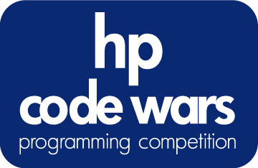

Check Please?
Problem #5 | Novice | 5 Points

C programmers: your program name must be: prob05.exe
JAVA programmers: your program name must be Prob05.class

Task Description
The menu for the local Lone Star Diner is as follows:

COFFEE – $0.50
SODA - $1.00
MILKSHAKE - $2.13
PANCAKES - $3.25
WAFFLES - $3.92
HAMBURGER – $4.01
PASTA - $4.44
HOTDOG - $2.98
CHIPS - $0.65
FRIES - $0.99

Write a program that takes a given list of menu items that have been ordered and displays the total bill.

Program Input
The customer’s order is contained in am input file (c:\codeware\prob05.in). The input file will contain a list of items ordered by the customer. Each item will be on a separate line. “END” will signify the end of the order. You can assume that all of the items in the order will be spelled correctly.

COFFEE
COFFEE
WAFFLES
PASTA
END

Program Output
The total cost of the order, as follows:

Your total is $9.36

